CST 4500 Penetration Testing and Digital Forensics. LAB 1.

Q1.     C:\>help ping

ANS.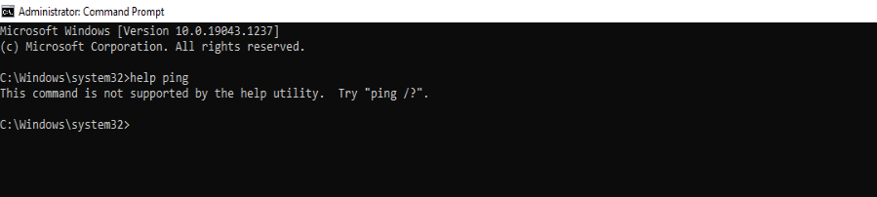

         C:\>ping /?

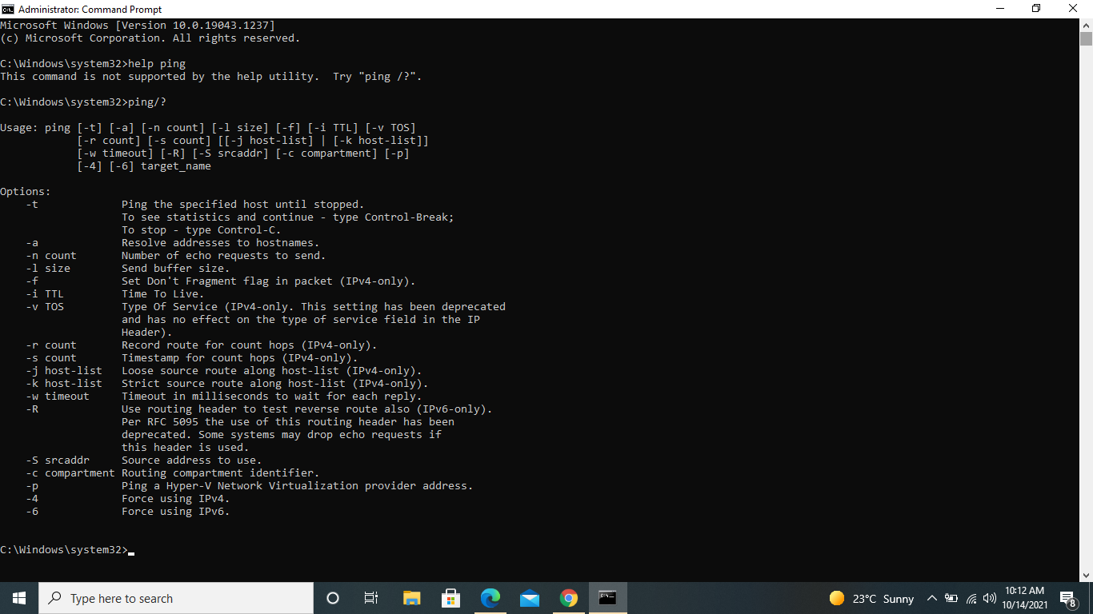

Q 2.    To List contents of a directory or folder.

           C:\>dir

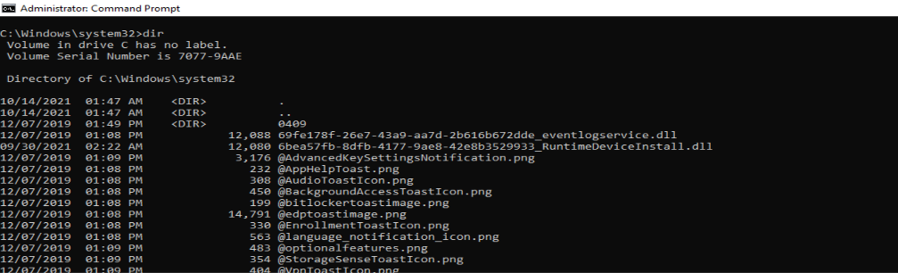

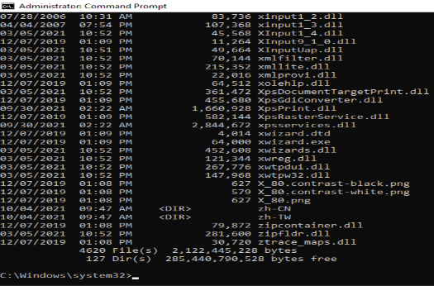

Q 3   To change Directory   C:\>cd Windows\System32

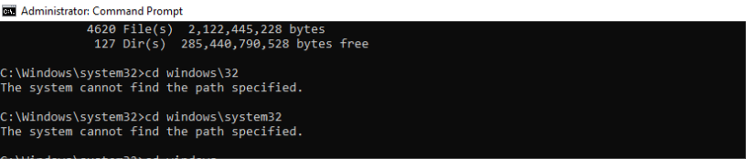

The machine is already in c:\Windows\system32. Hence it remained in the same directory, with error message “the system cannot find the path specified”.

Q 4 To access another drive D:\ for instance type C:\>d:

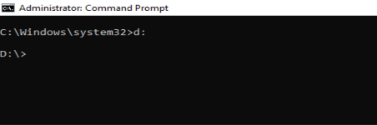

   To change the drive and the directory at the same time,  D:\> cd/d C:\Windows

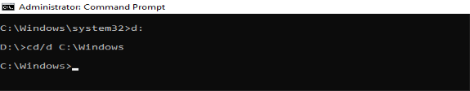

    It goes back to C drive and into the windows folder.

Q 5 To create a new folder or directory; C:\> mkdir test folder

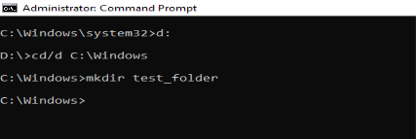

To check if folder has been created C:\>dir test_folder

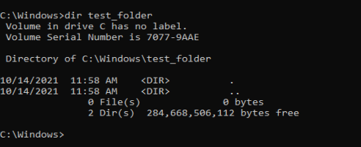

Q 6   To create a text file, use the command (echo) as follows: C:\Source>echo >file1.txt

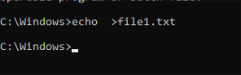

Q 7  Create a new folder Destination

    a    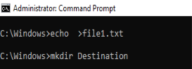

    b.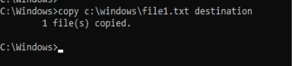

  Now try to copy file1.txt to another folder on the D: drive. Write the command below

                C:\Windows>copy c:\windows\file1.txt d:\

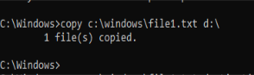

Q 9    To Delete a folder

             C:\Windows>del c:\windows\destination\ file1.txt

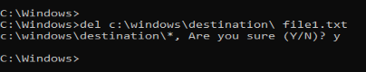

Q 10. Run a program from command prompt. C:\Windows\System32>mspaint.exe

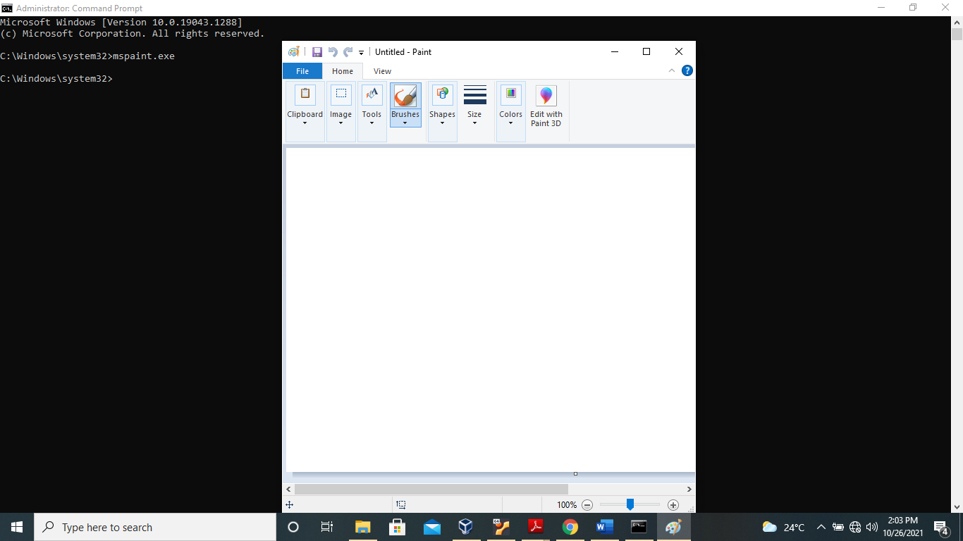

Task 2: Administrative commands and command line tools for network configuration

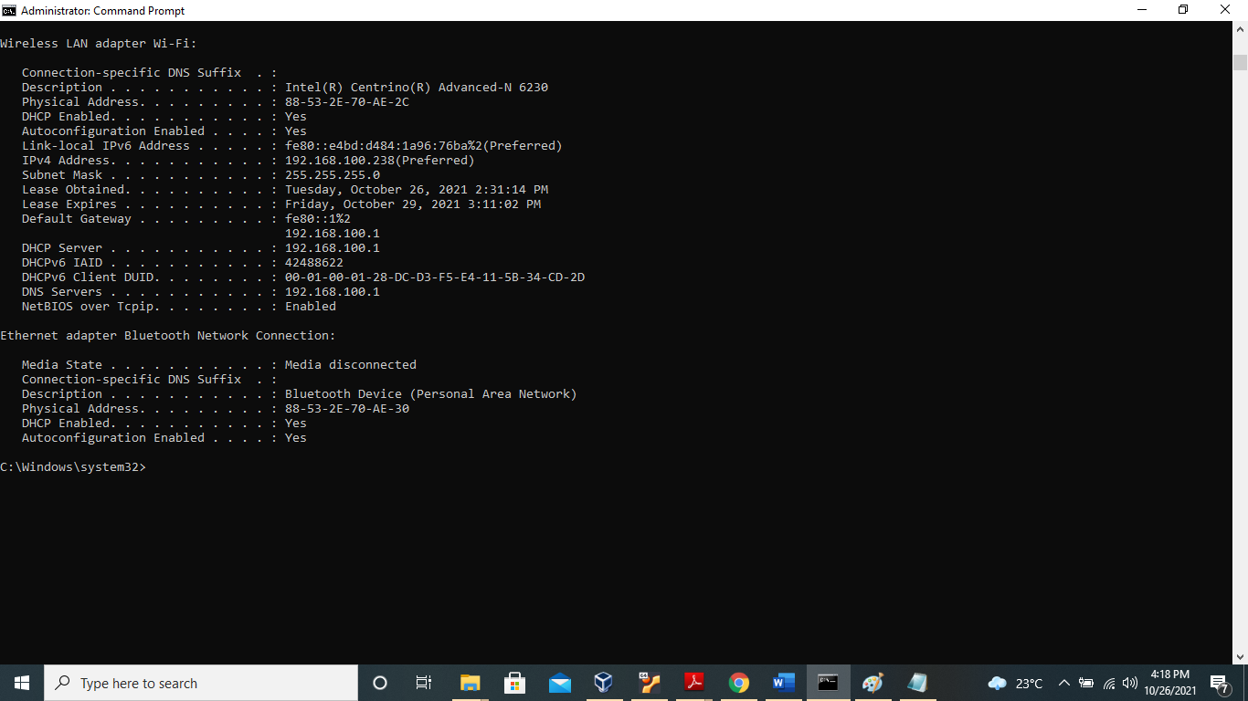

IP ADDRESS: 192.168.100.238

SUBNET MASK:  255.255.255.0

DEFAULT GATEWAY:  192.168.100.1

Ping the Default gateway:

Ping 192.168.100.1

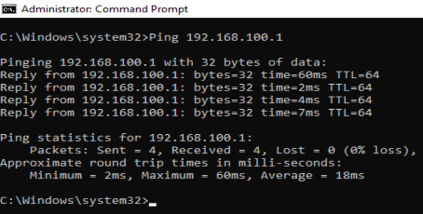

Ping successful.

Try to ping the IP address of any DHCP and/or DNS servers listed in the last exercise.

Ping192.168.100.1.

Ping was successful. Same as default gate way.

Ping loopback 127.0.0.1.

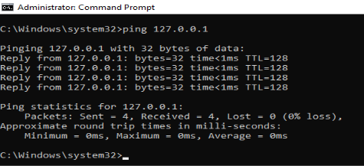

Ping was successful.

Ping Hostname DESKTOP-Q175990

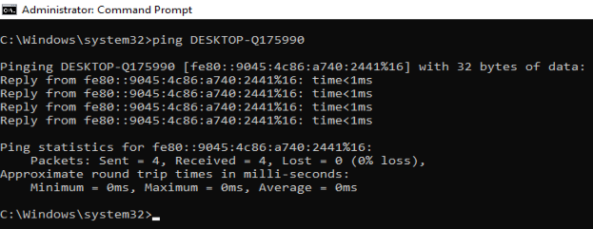

Type tracert at the command prompt, followed by a host name or IP address from your working area

  Tracert DESKTOP-Q175990

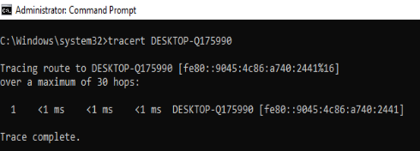

Type tracert followed by a url address from a website (e.g. [www.google.com](http://www.google.com/))

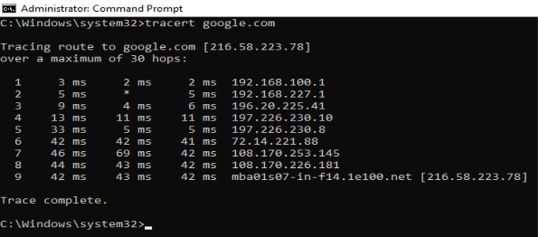

Tracert in the same working area or on the same network is completed in less time with lesser hops as compared to tracert to an external hostname or ip address which takes a slightly longer time and more hops, depending on destination.

|  |  |  |
| --- | --- | --- |
| tracert | Number of hops | Time to destination |
| DESKTOP-Q175990 | 1 | 1 ms |
| www.google.com | 9 | 42ms |